**Executive Summary**

Hypertension refers to a systolic blood pressure of 130 mmHg or higher and a diastolic blood pressure of 80 mmHg or higher1,2. It affects about 116 million (47%) adults in the United States1. In the elderly, a high systolic blood pressure shows a higher risk of stroke and heart disease as compared to a high diastolic blood pressure3. According to existing literature, various risk factors have been linked with hypertension. Obesity was found to be a major risk factor, with a 5% weight gain associated with a 30% risk of developing hypertension in 4 years4,5. Other risk factors found were Age greater than 60 years, Male sex, Presence of Diabetes, High levels of Total Serum Cholesterol, and Smoking status.

The dataset used was the Framingham Heart Study which included clinic examination data of cardiovascular disease risk factors and markers of disease from 4,434 participants with 11,627 observations. The dataset was downloaded and cleaned, and a hierarchical multiple linear regression was run using IBM SPSS Statistics 29.0. The Dependent Variable was Systolic Blood Pressure. The Independent Variables were Body Mass Index, Age (>60 years), Sex, Presence of Diabetes, Total serum cholesterol, and Smoking status. Three research questions were tested; whether there is a statistically significant linear model that can predict systolic blood pressure from Body Mass Index, whether each independent variable in the model is statistically significant, and the significance of adding Age (>60 years), Sex, Presence of Diabetes, Total serum cholesterol, and Smoking status to the model.

From the results, we found that there is a statistically significant linear model that can predict systolic blood pressure from Body Mass Index. All the individual risk factors were found to have a statistically significant association with systolic blood pressure. After the other variables were added, the newer models predicted the systolic blood pressure better than the previous ones, with the third model being the best at predicting systolic blood pressure. Age >61 years and Body mass index were the most important risk factors found after Age and the presence of Diabetes were accounted for. However, when Total serum cholesterol, smoking status, and sex were accounted for, the presence of diabetes was found to be the most important predictor of systolic blood pressure.

With the above model, an interactive dashboard was made to predict systolic blood pressure from the various variables in RStudio using the Shiny package. The targeted users of the dashboard are employers who can use it to predict new and existing employees’ risk of high blood pressure and associated complications after routine medical screening is done to determine those who need to be referred for further professional healthcare.

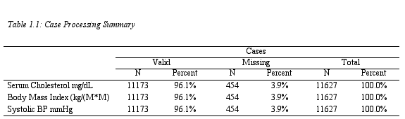

Large Sample Size



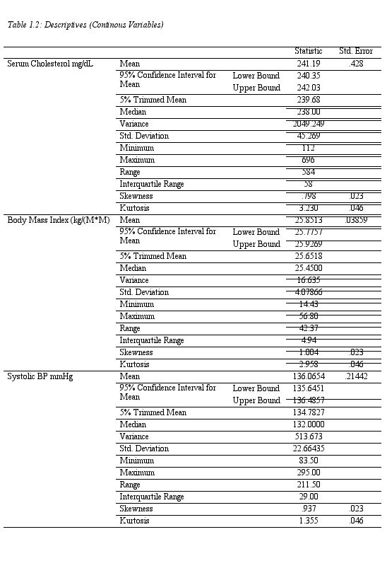

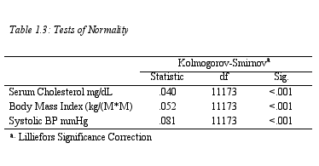

Variables are not normally distributed but due to the large sample size, MLR can be run. The residuals would be checked afterwards for normality.

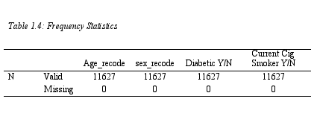

|  |  |  |
| --- | --- | --- |
| **Frequency Table** | | |
| **Age > 60 years** | **Yes** | **No** |
| **Number** | 3389 | 8238 |
| **Percentage** | 29.1 | 70.9 |
|  | | |
| **Sex** | **Male** | **Female** |
| **Number** | 5022 | 6605 |
| **Percentage** | 43.2 | 56.8 |
|  | | |
| **Diabetic Status** | **Yes** | **No** |
| **Number** | 530 | 11097 |
| **Percentage** | 4.6 | 95.4 |
|  | | |
| **Cigarette Smoking** | **Yes** | **No** |
| **Number** | 5029 | 6598 |
| **Percentage** | 43.3 | 56.7 |

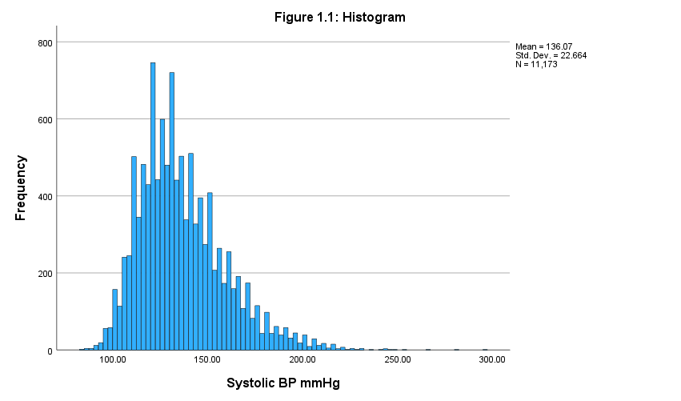

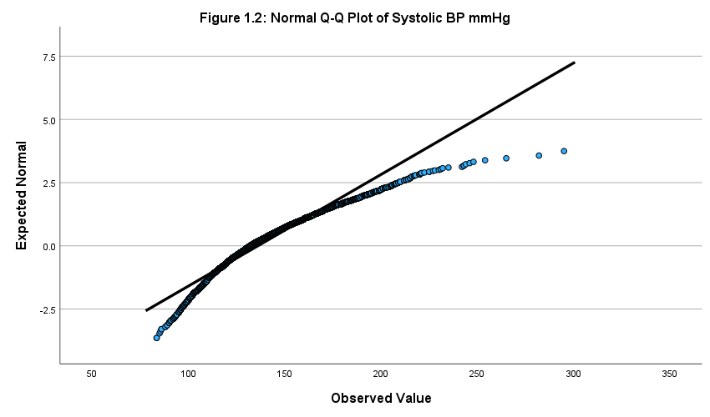

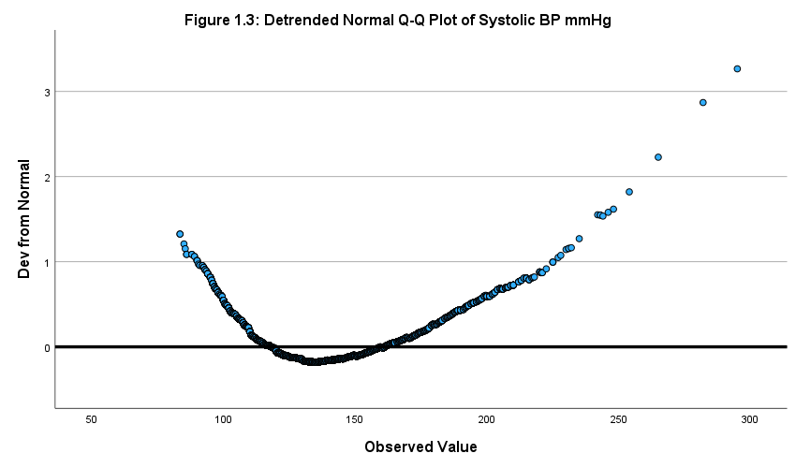

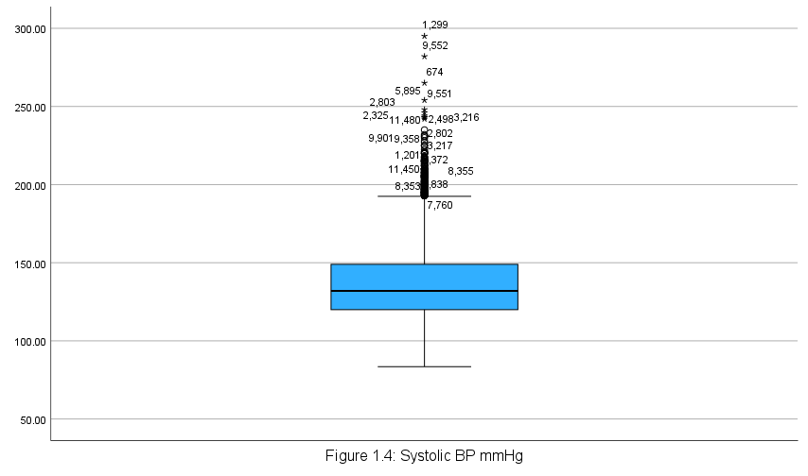

**Regression**

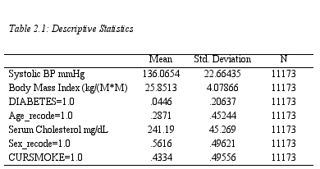

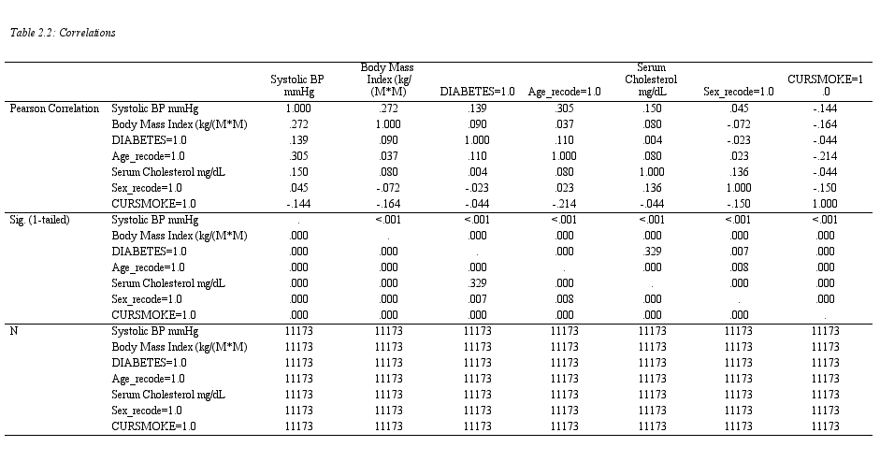

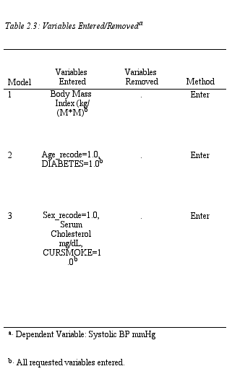

The 3 models predict better than the mean.

The 2nd model predicts better than the 1st model and the 3rd model predicts better than the 2nd.

7.4% of the variability in Systolic BP is explained by BMI.



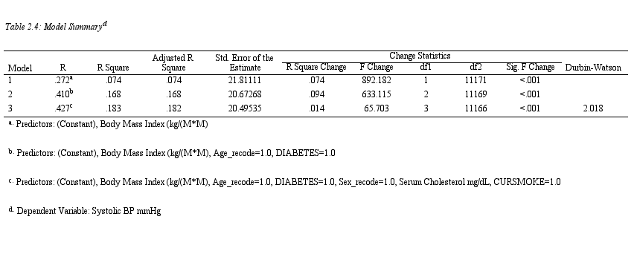

16.8% of the variability in systolic bp was explained by the model after Age and Diabetes status were accounted for. After further accounting for Sex, cholesterol levels, and smoking status, the model explained 18.2% of the variability in Systolic BP.



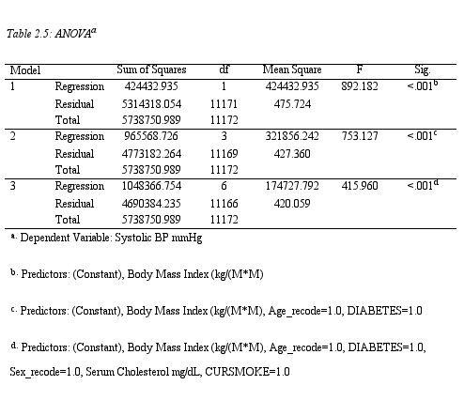

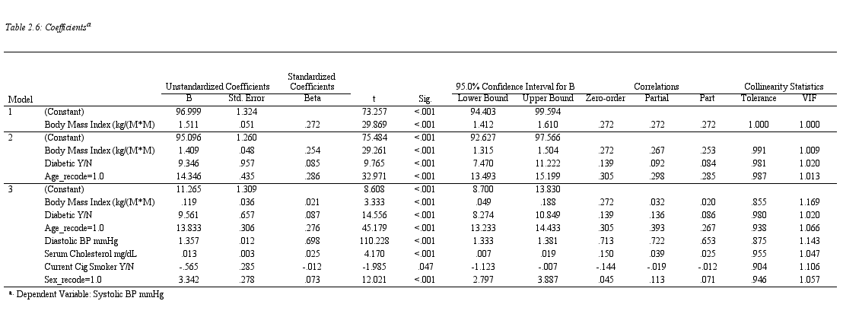

After accounting for Serum cholesterol, smoking status and sex in the presence of the other factors, Diabetic status was found to be the most important variable.

The most important independent variables in this model were BMI and Age > 60 years.



There is a statistically significant association between the dependent variable and all the independent variables.



There is a statistically significant model that can predict systolic blood pressure from Body mass index.

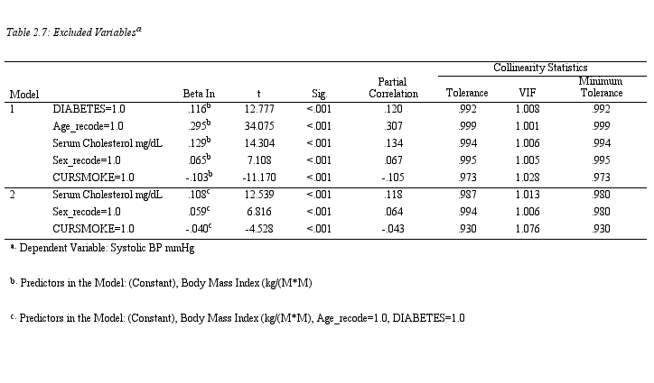

No collinearity is present.

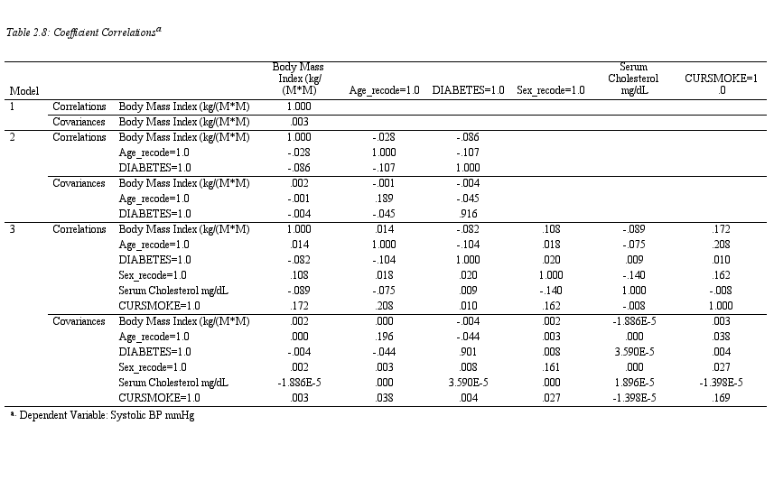

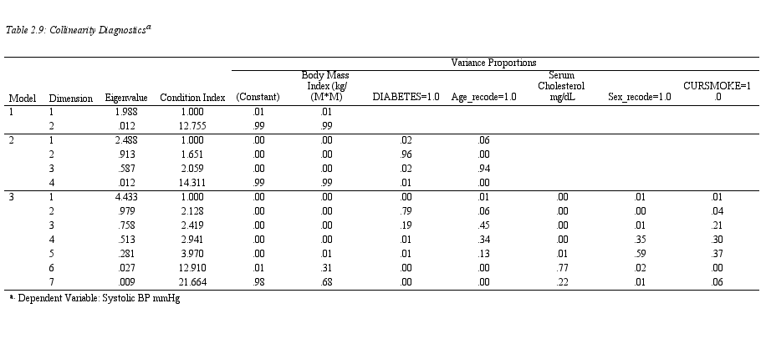

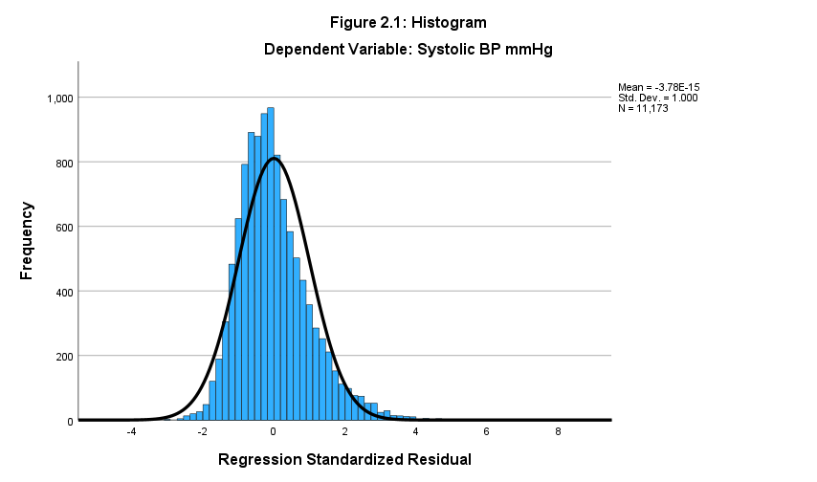

Residuals are normally distributed.

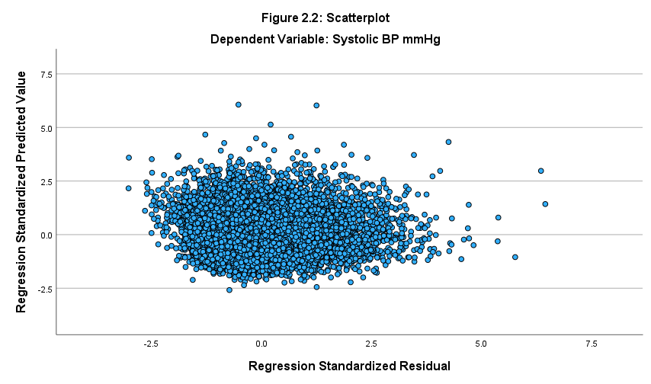

Scatterplot of the standardized residuals is homoscedastic.

**Interactive Dashboard**

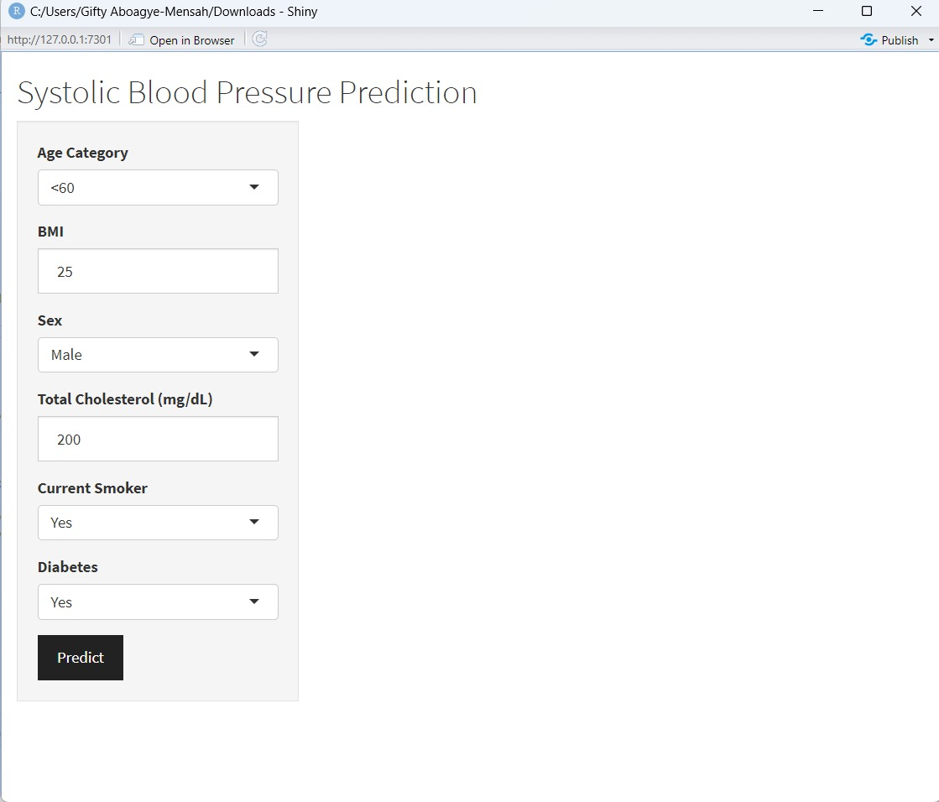

The area where predicted systolic blood pressure is displayed.

Button to click on after the right parameters have been selected.

Systolic Blood pressure calculated for a Man, who is more than 61 years old, who smokes, and has diabetes. He also has a total serum cholesterol of 189mg/dl.

**References**

1. High blood pressure (hypertension) - Symptoms & causes - Mayo Clinic. Accessed March 14, 2024. https://www.mayoclinic.org/diseases-conditions/high-blood-pressure/symptoms-causes/syc-20373410

2. Hypertension. Accessed March 14, 2024. https://www.who.int/news-room/fact-sheets/detail/hypertension

3. Which blood pressure number is important? Harvard Health. Published November 1, 2018. Accessed March 14, 2024. https://www.health.harvard.edu/staying-healthy/which-blood-pressure-number-is-important

4. MD DAM. Obesity and Blood Pressure. News-Medical. Published March 31, 2013. Accessed March 14, 2024. https://www.news-medical.net/health/Obesity-and-Blood-Pressure.aspx

5. Landi F, Calvani R, Picca A, et al. Body Mass Index is Strongly Associated with Hypertension: Results from the Longevity Check-Up 7+ Study. *Nutrients*. 2018;10(12):1976. doi:10.3390/nu10121976